**A report about the buildings in MAKERERE UNIVERSITY.**

**By: NANTALE MARY VIVIAN**

**15/U/10829/PS**

**215013868**

**19th May 2017**

**Table of Contents**

Title…..………………………………………………………………………….1

Introduction ………………………………………………………………...3

The description of various buildings………………………………3

Problems faced when collecting data…………………………….3

Possible solutions to the problems………………………………..4

Sample Screenshots of the Phone Application……..…………..4

The summary……………………………………………………………………6

Conclusion………………………………………………………………………7

**Introduction**

The purpose of my research concept is to find out what some of the existing buildings forming the great infrastructure of Makerere University. Here I was able to find out the positions of the buildings using GPS coordinates, the pictures of the buildings, their names, purpose in the university, maximum number of people the different buildings can accommodate, and number of floors for storied buildings

**Executive summary**

Makerere University covers a very wide area and consists of a variety of infrastructure. This makes it hard for new people to the university to get access to the various buildings. Therefore, research has been carried out to get such information so as to solve this problem.The current signs put in place in the university are fading thus becoming invisible to those that need directions to different places.

**The description of various buildings.**

The different buildings in Makerere University consist of students’ halls of residence, faculty buildings, library book banks, places of worship like a mosque, administration blocks, and restaurants. These all serve different purposes to the students, teaching and non-teaching staff. The buildings are either constructed with blocks or other materials like wood.

**SCOPE**

The concept shows how a mobile phone application, ODK COLLECT was used to gather information about the various buildings in Makerere University.

**Problems faced when collecting data.**

* Unforeseen weather changes where the rain was a hindrance to my movement around the different buildings.
* Poor connection within the university which couldn’t enable me connect to the server efficiently.
* High security measures on some buildings which would make it illegal to take pictures because it would be considered as a threat.
* Lack of accuracy when finding the GPS coordinates.

**Possible solutions to the problems**

* Better means of transportation around campus as kit would make the research work faster.
* Communication towers are being built in Makerere University so as to deal with the problem of poor network.
* Better preparation before carrying out research through use of better equipment.

**Sample Screenshots of the Phone Application**

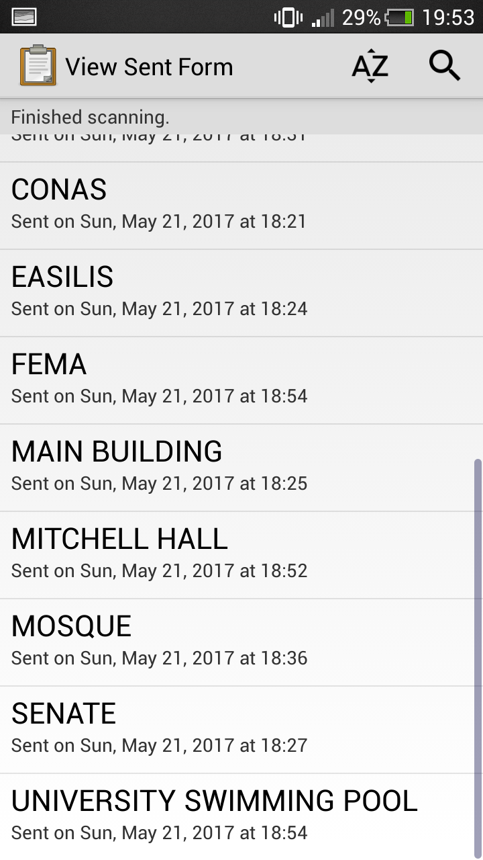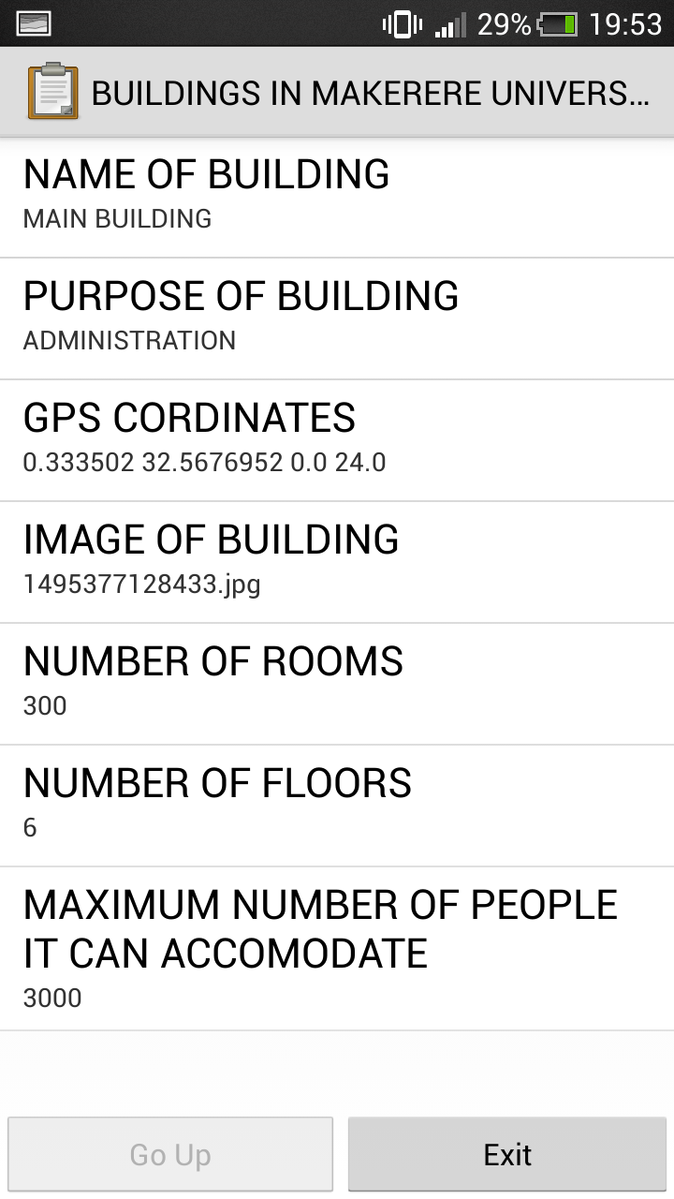

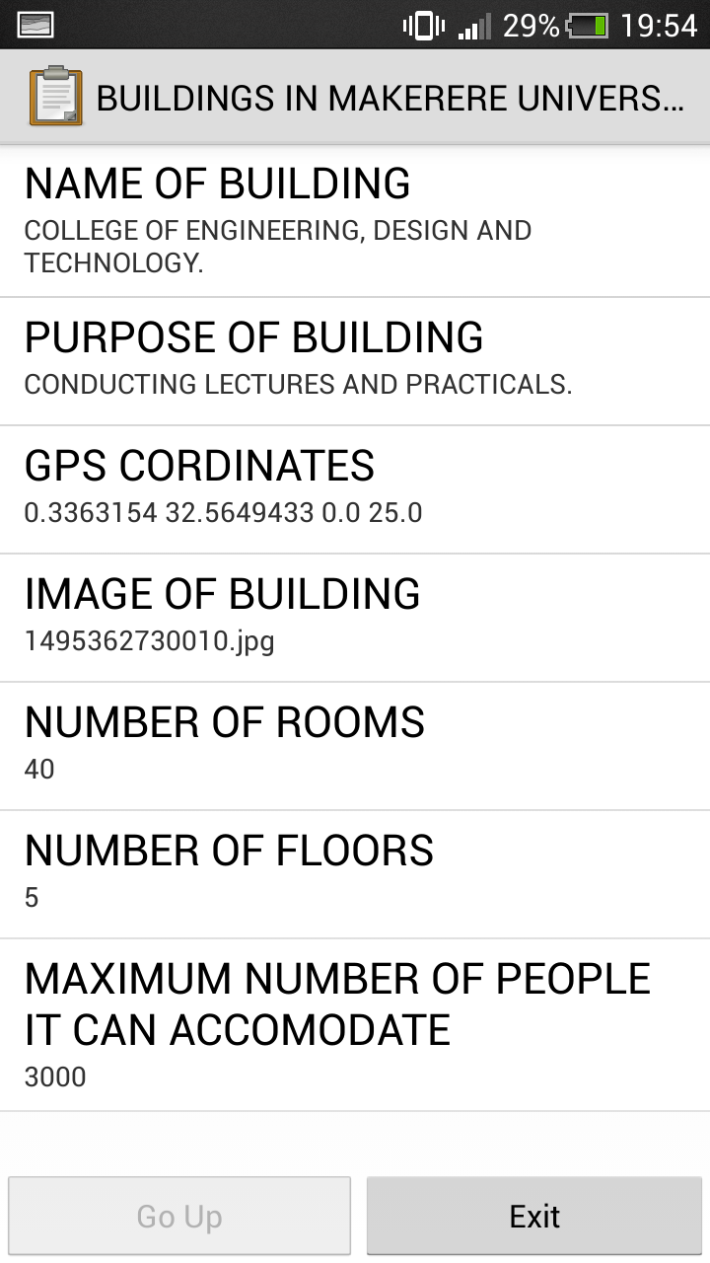

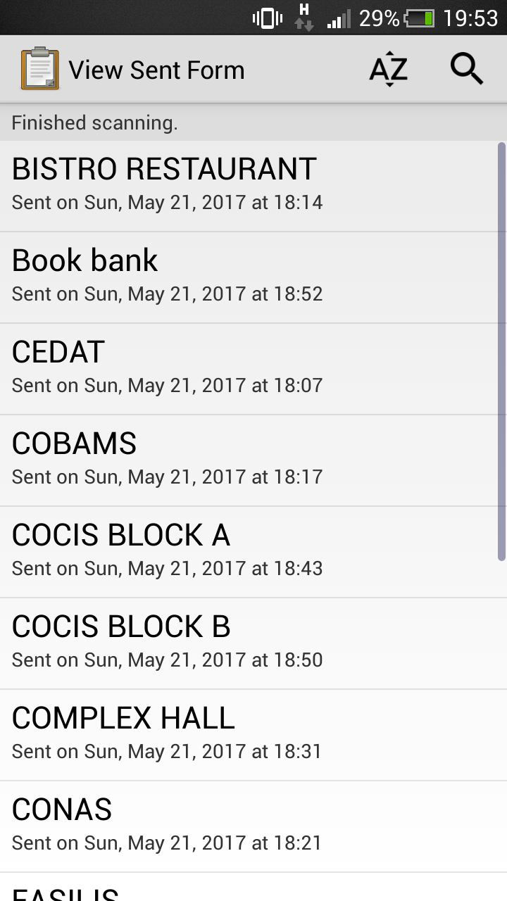

THE SUMMARY

|  |  |  |  |  |  |  |  |
| --- | --- | --- | --- | --- | --- | --- | --- |
| **NAME** | **PURPOSE** | **Latitude** | **Longitude** | **LOCATION:Accuracy** | **rooms** | **NUMBER** | **PEOPLE** |
| COLLEGE OF ENGINEERING, DESIGN AND TECHNOLOGY. | CONDUCTING LECTURES AND PRACTICALS. | 0.3363154 | 32.5649433 | 25 | 40 | 5 | 3000 |
| BISTRO RESTAURANT | HAVING MEALS | 0.3350754 | 32.5662028 | 1351 | 2 | 1 | 100 |
| COBAMS | EDUCATION | 0.335625 | 32.5660033 | 28 | 100 | 4 | 2000 |
| COLLEGE OF NATURAL SCIENCES | EDUCATION | 0.3350816 | 32.5667316 | 35.013 | 50 | 3 | 2000 |
| EASILIS | EDUCATION | 0.3347886 | 32.5669703 | 24 | 10 | 3 | 2000 |
| MAIN BUILDING | ADMINISTRATION | 0.333502 | 32.5676952 | 24 | 300 | 6 | 3000 |
| SENATE | OFFICE OF THE REGISTRAR | 0.3323331 | 32.5698607 | 34 | 250 | 6 | 5000 |
| COMPLEX HALL | ACCOMODATE GIRLS | 0.3295321 | 32.5700979 | 27 | 300 | 3 | 1000 |
| MOSQUE | PRAYERS | 0.3314255 | 32.5715196 | 40.5 | 2 | 1 | 200 |
| COLLEGE OF COMPUTING AND INFORMATION TECHNOLOGY. BLOCK A | EDUCATION AND INNOVATIVENESS | 0.3314614 | 32.5704582 | 41 | 35 | 6 | 2000 |
| COLLEGE OF COMPUTING AND INFORMATION TECHNOLOGY BLOCK B | EDUCATION AND INNOVATIVENESS | 0.3317079 | 32.5703998 | 44.123 | 35 | 6 | 5000 |
| UNIVERSITY BOOKSHOP | SELLING AND LENDING BOOKS | 0.3314613 | 32.5705661 | 25 | 1 | 1 | 20 |
| MITCHELL HALL | ACCOMODATE MALE STUDENTS | 0.3314617 | 32.5705662 | 25 | 800 | 4 | 1500 |
| Swimming pool | LEISURE | 0.3349042 | 32.5688945 | 36 | 4 | 1 | 500 |
| SCHOOL OF ECONOMICS | EDUCATION | 0.3349868 | 32.5686567 | 25.29 | 150 | 6 | 2000 |

**Conclusion**

In conclusion, this research will help to solve the problem of searching for the different buildings depending on one’s needs in the University.